***Network Security LAB-8***

***Jihan Rakesh Jain, 1RVU22CSE070***

Pinging without VPN   
  
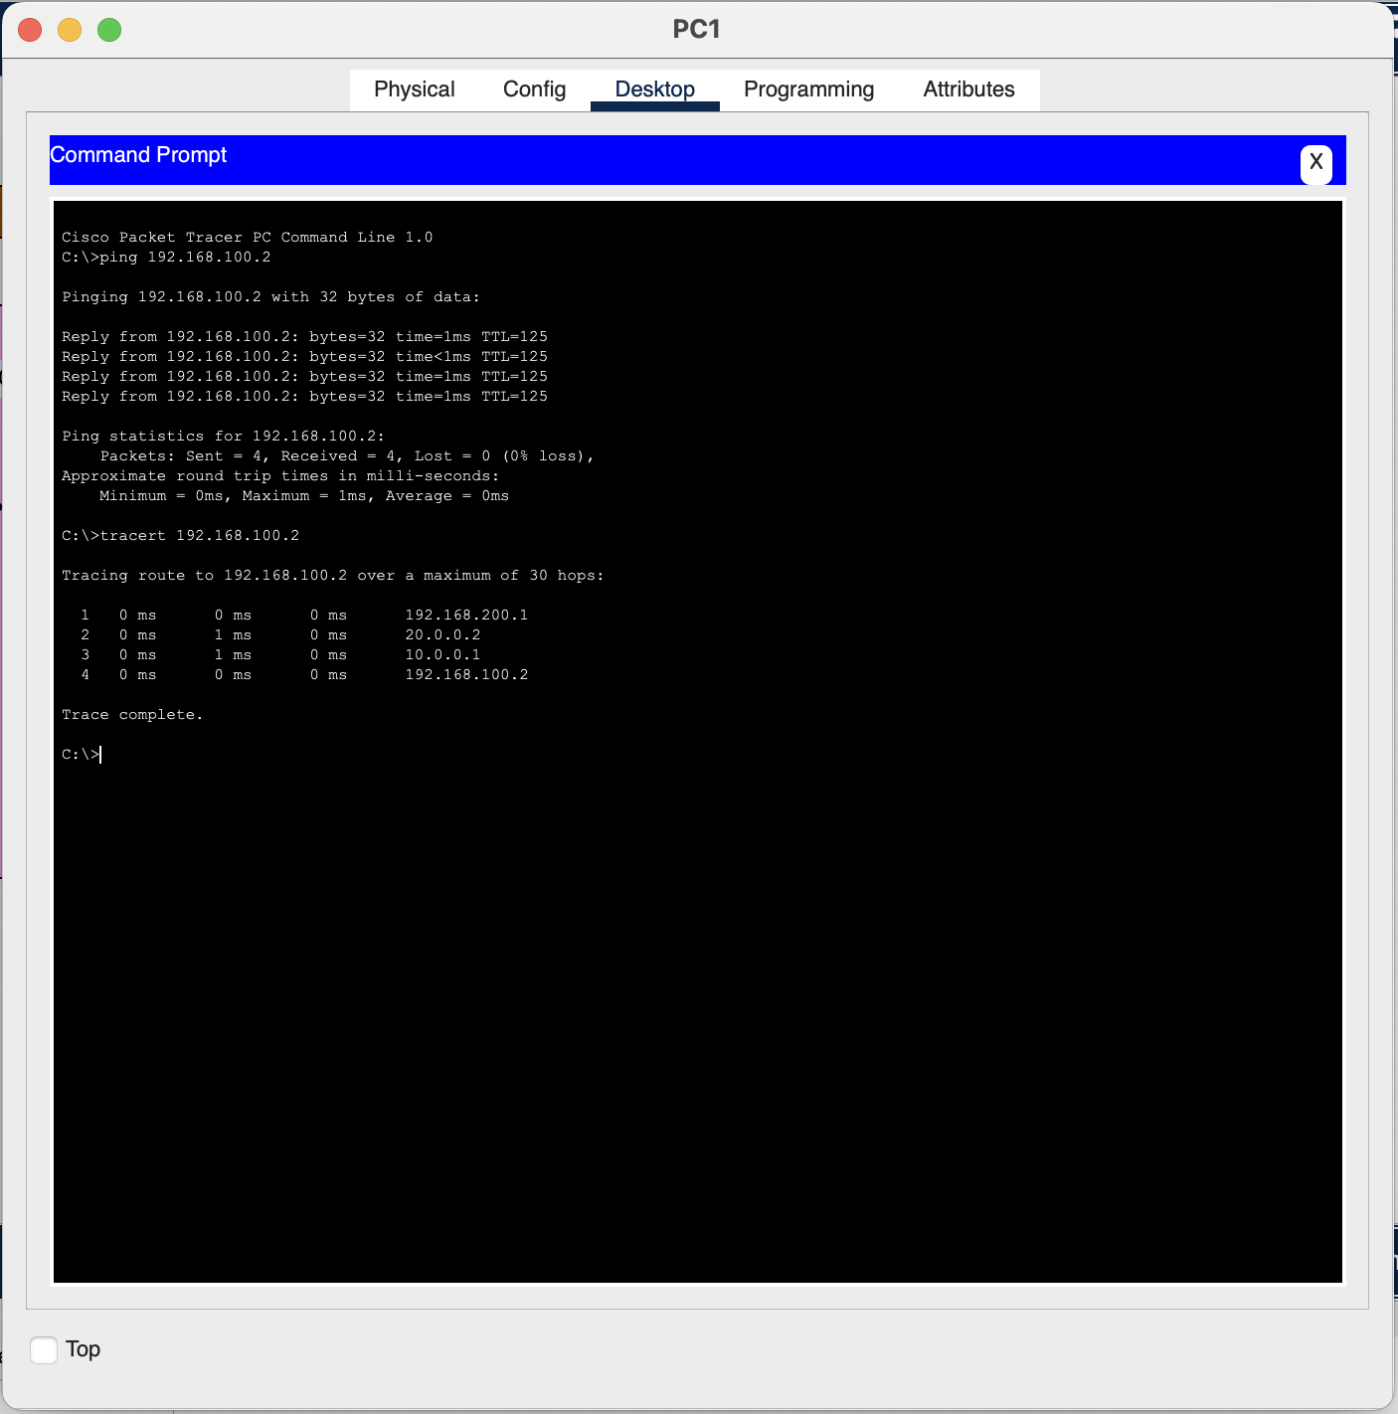

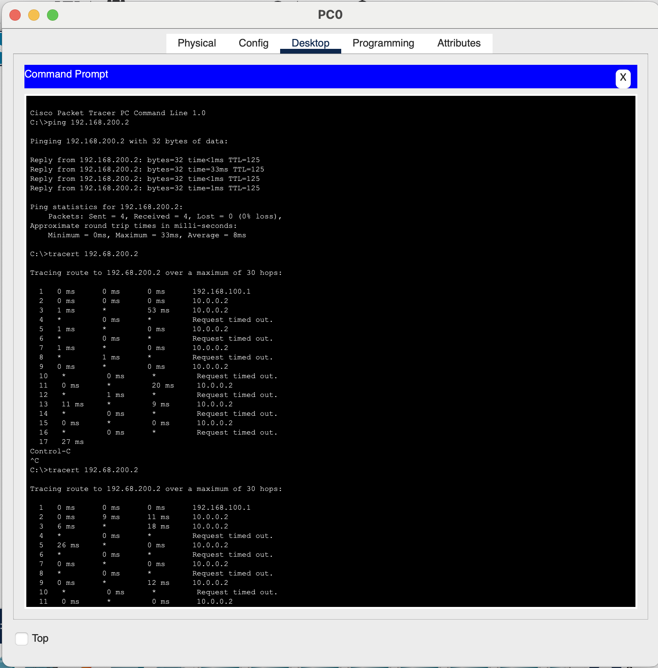

Configuring VPN, Router0  
  
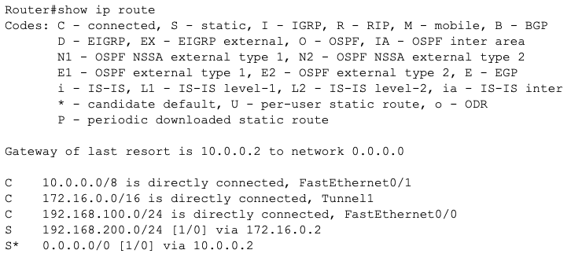

Configuring VPN, Router1

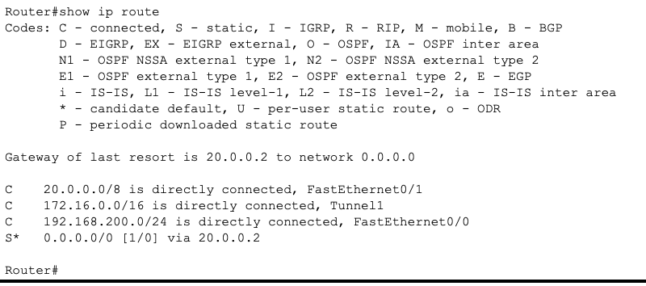

Ping PC0 to PC1

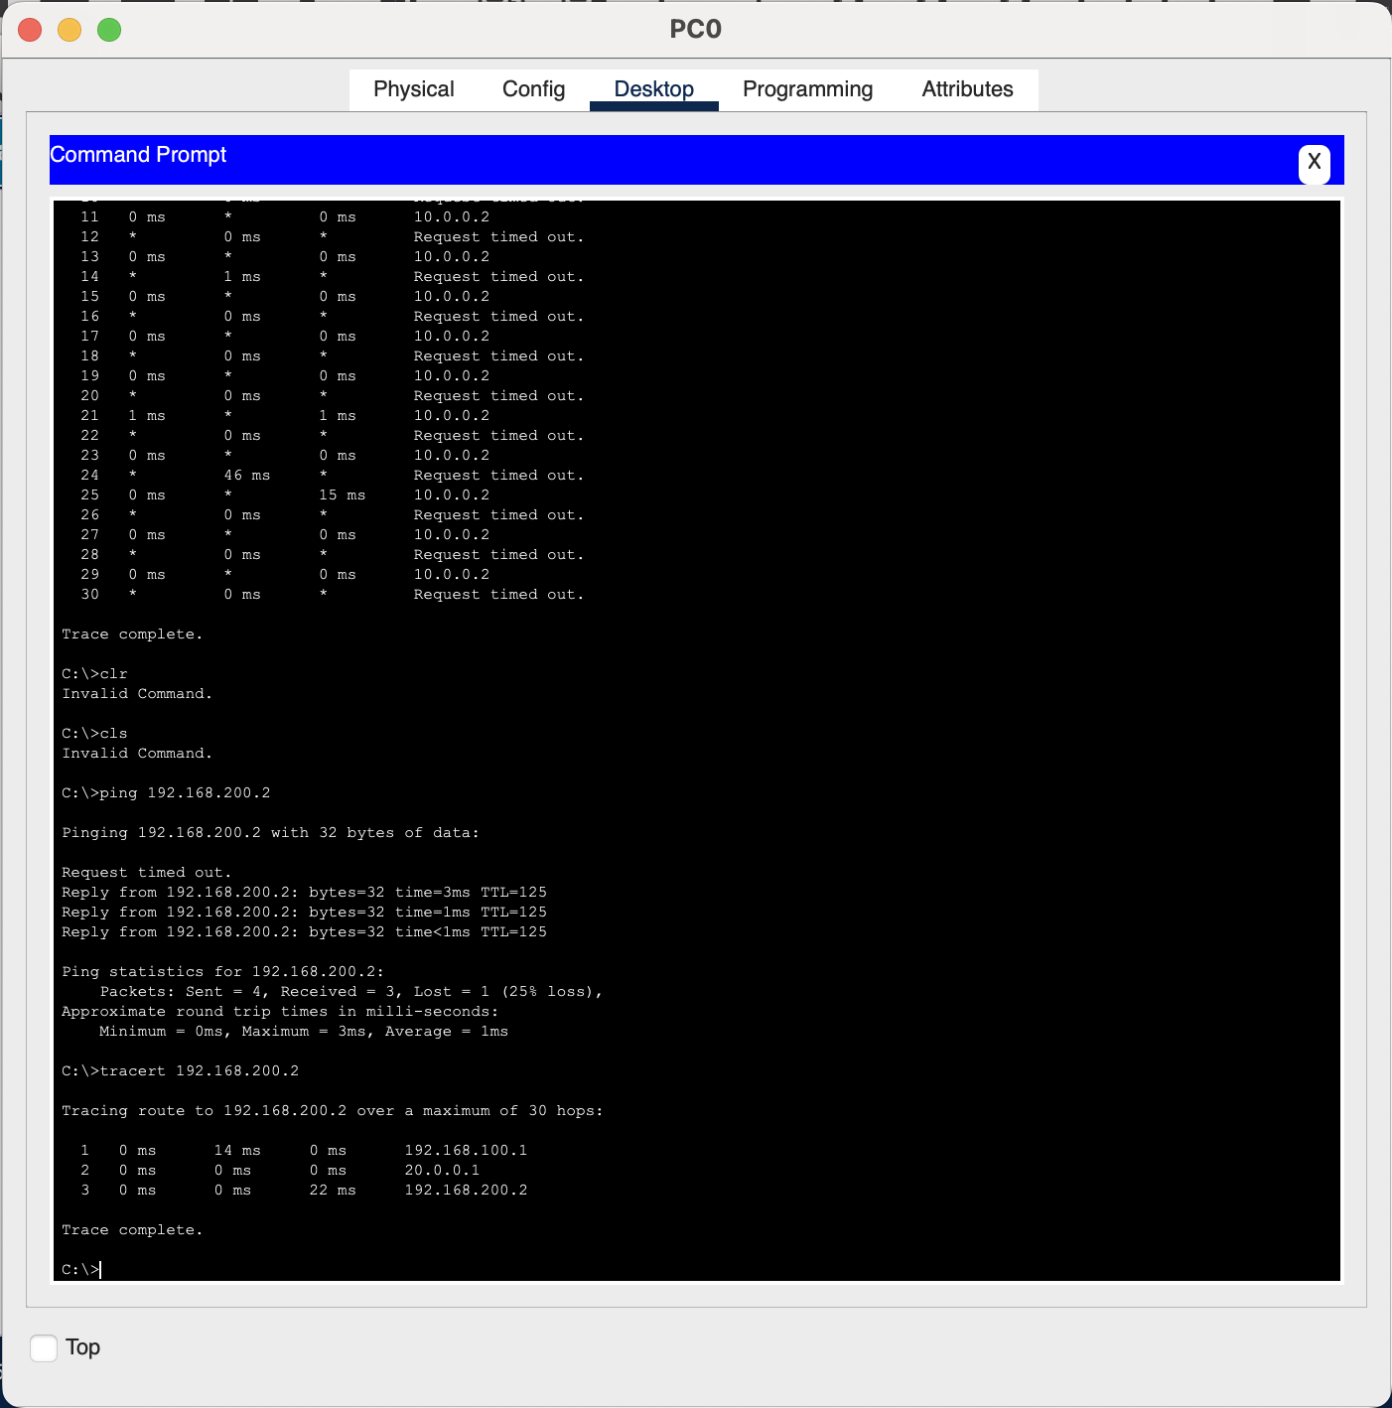

Ping PC1 to PC0

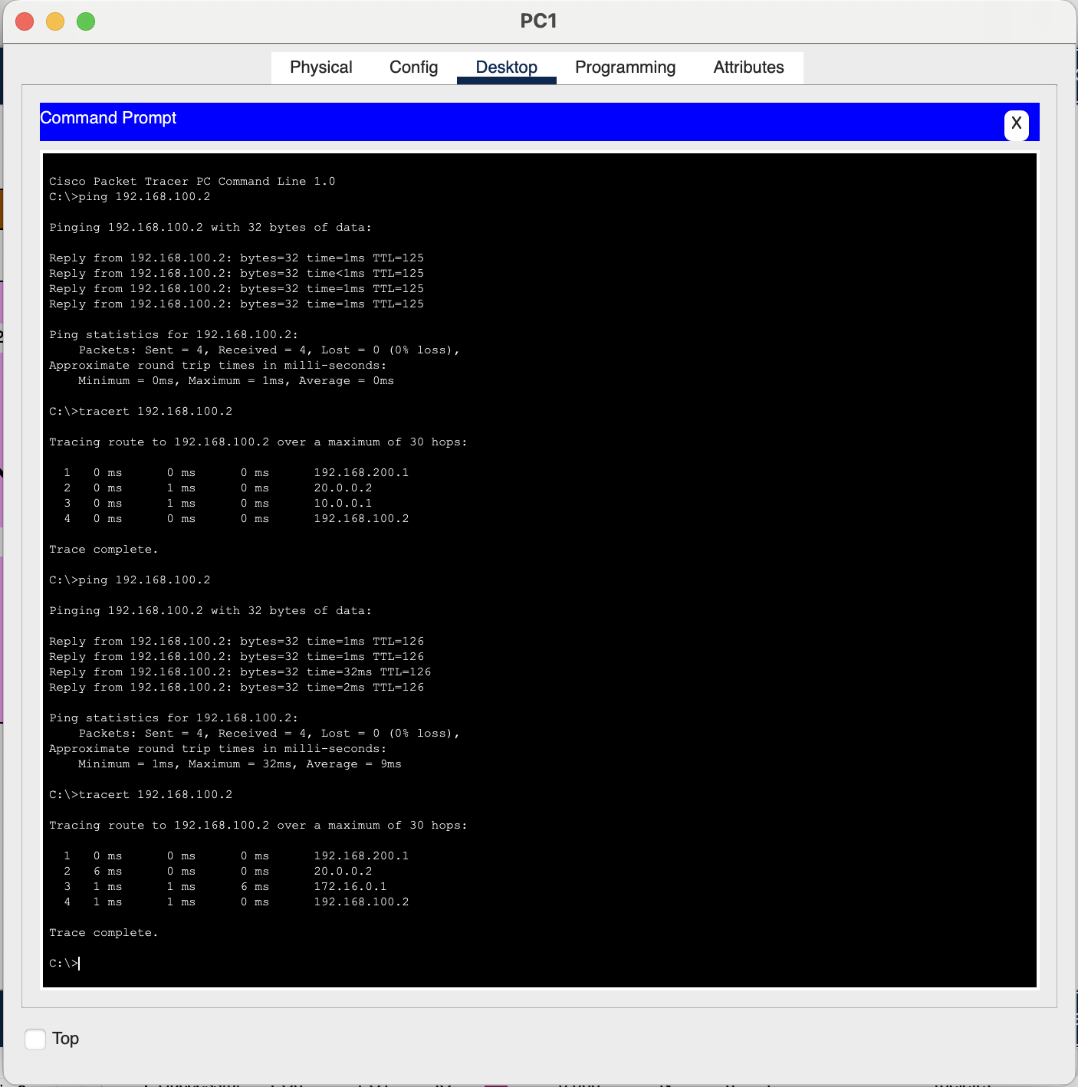

Sniffer

